ECON0004 TUTORIAL 3
Deadline for submission is 11:59pm on Wednesday, 18 Feb, 2026.

Submission Instruction:
Similar to Tutorial 2 assignment, you are expected to submit two files:
- Main submission (Word or PDF), which should include:
  - Your answers to parts 1, 4(b) and 4 (c), the chart you plot for part 4(a) , and the correlation coefficient result you calculate for 4(b).
  - Your answers to Question 2 along with the OLS regression output tables.
  - Your answers to Question 3.

- Jupyter Notebook, which includes the code used to generate the plot and compute the correlation coefficient for Question 1, as well as the code used to run the OLS regressions for Question 2.

Question 1:
Answer question 1 and question 4 in Part 1.3 Carbon emissions and the environment of empirical project 1 “Measuring Climate Change” (working in Python) in the ebook “Doing Economics: Empirical projects”. Please note the following:

  - For questions 4, choose a month different from the one used in the solution and produce a chart similar to Figure 1.9. There is no need to reproduce Figures 1.10 and 1.11, as you already practiced plotting time-series data in the previous tutorial.
  - The Python walk-through uses “ggplot”, which is available in Jupyter Notebook but not installed by default. To use it, you need to install plotnine and then import ggplot as follows: pip install plotnine from plotnine import ggplot

Answer for Question 1

1

Question 2:
You can find the data for this question in the “Tutorial 3” folder on moodle. The data are a sample of 300 male manual workers from the UK. We are interested in the regression of lnwage (lnwage) on education (educ):

lnwage_{i} = α + βedu_{i} + ε_{i}

  - Regress ln wage (lnwage) on education (educ). Interpret your results.
  - Can you reject the hypothesis that an additional year of schooling increases wages by 1%?
  - What is the R² of the regression? Give the formula and explain what it is in words.
  - Add years of experience (exp) to the regression. What happens to the estimated effect of education? Explain why this happens.

Answer

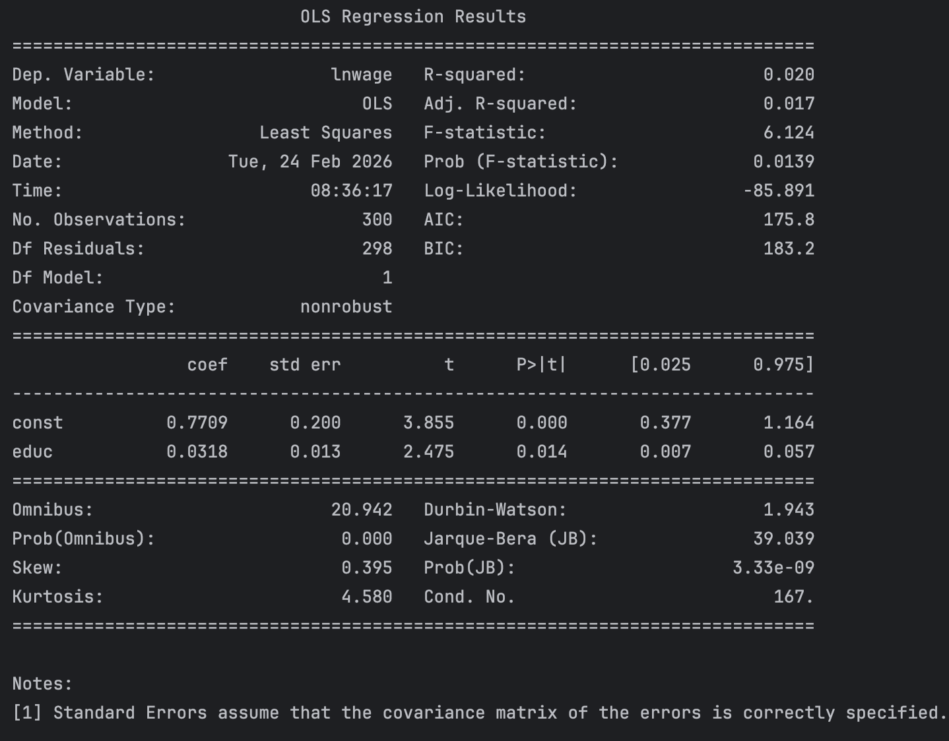

b)
c)

d)
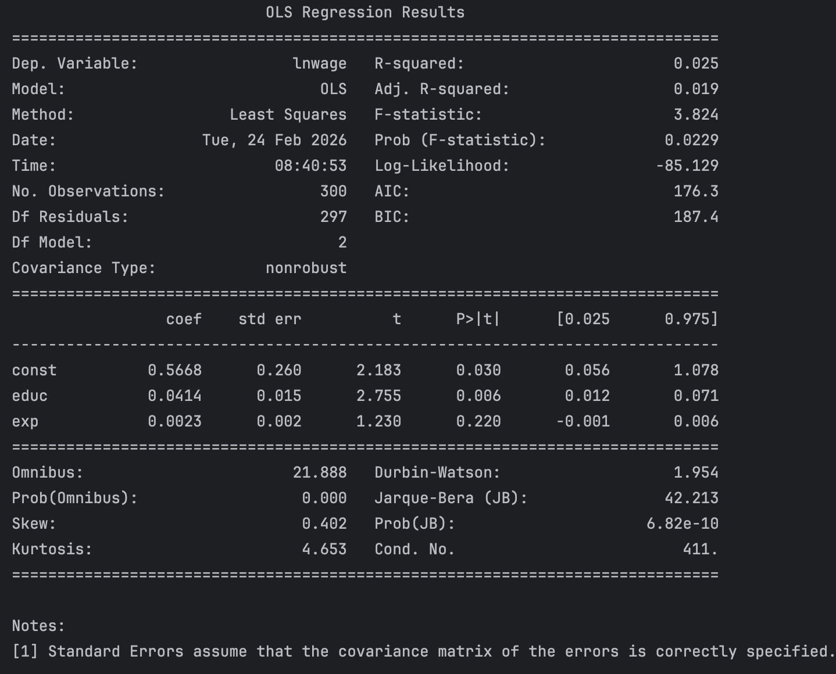

Question 3:
Consider the following wage equation that has been estimated from a random sample of 35-65 year old male workers:

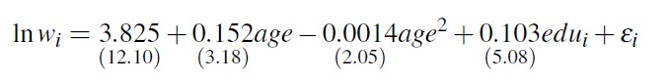

where lnw is log wage, age is age measured in years, edu is a dummy variable indicating if the individual has higher education qualifications. The numbers in parentheses are absolute t-ratios.

- What is the return to additional year of age?
- Test the hypothesis that the return to age is constant.
- When does the return to age fall to zero?

2

